AI Assistant Coding
Assignment 6.1
Name : Arun
Roll No : 2303A52064
Batch – 32

Task1 Description
#1 (Loops – Automorphic Numbers in a Range)
• Task: Prompt AI to generate a function that displays all Automorphic
numbers between 1 and 1000 using a for loop.
• Instructions:
o Get AI-generated code to list Automorphic numbers using a for
loop.
o Analyze the correctness and efficiency of the generated logic.
o Ask AI to regenerate using a while loop and compare both
implementations.
Expected Output #1:
• Correct implementation that lists Automorphic numbers using both
loop types, with explanation.
Prompt :
Code:
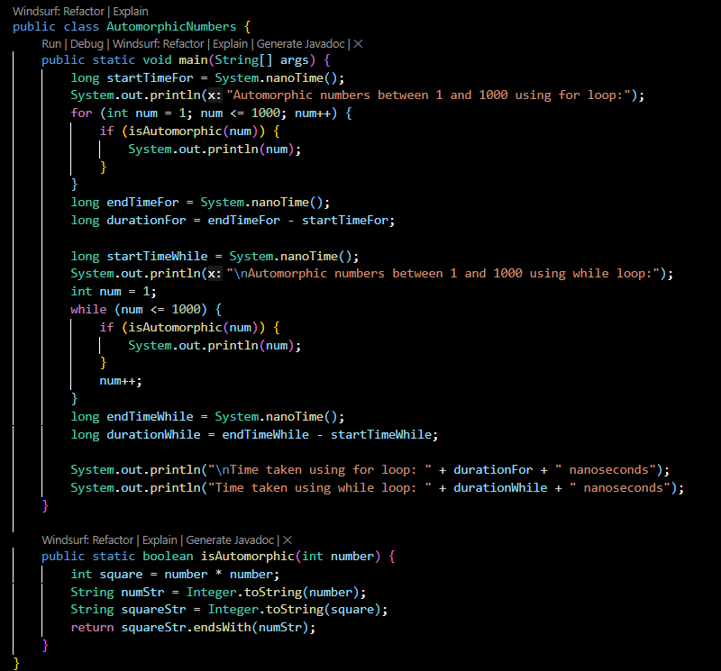
Output:
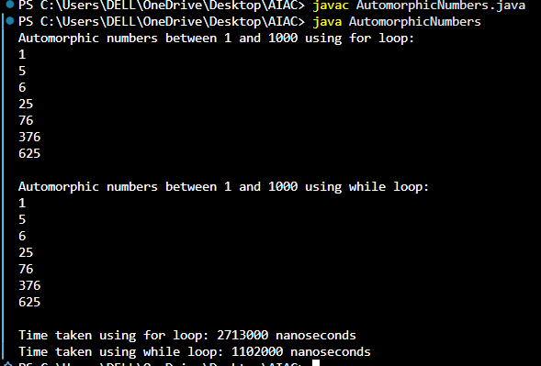
Explanation :
This Java program finds Automorphic numbers between 1 and 1000 using both for loop and while loop, and compares their execution time.
Iterates from 1 to 1000 using a for loop and prints automorphic numbers.
Repeats the same logic using a while loop.
Uses System.nanoTime() to measure the time taken by each loop.
The isAutomorphic() method checks whether the square of a number ends with the original number using string comparison.

Description #2
(Conditional Statements – Online Shopping Feedback Classification)
• Task: Ask AI to write nested if-elif-else conditions to classify online
shopping feedback as Positive, Neutral, or Negative based on a
numerical rating (1–5).
• Instructions:
o Generate initial code using nested if-elif-else.
o Analyze correctness and readability.
o Ask AI to rewrite using dictionary-based or match-case
structure.
Expected Output #2:
• Feedback classification function with explanation and an alternative
approach.
Prompt:
Code :
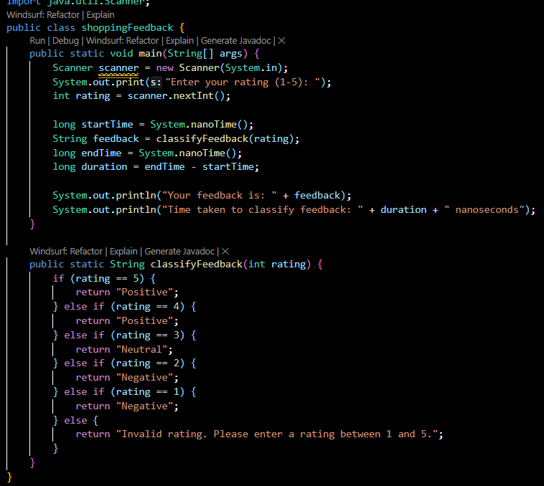
Output:
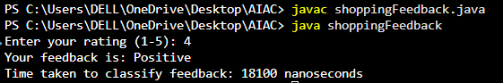
Prompt:
Code :
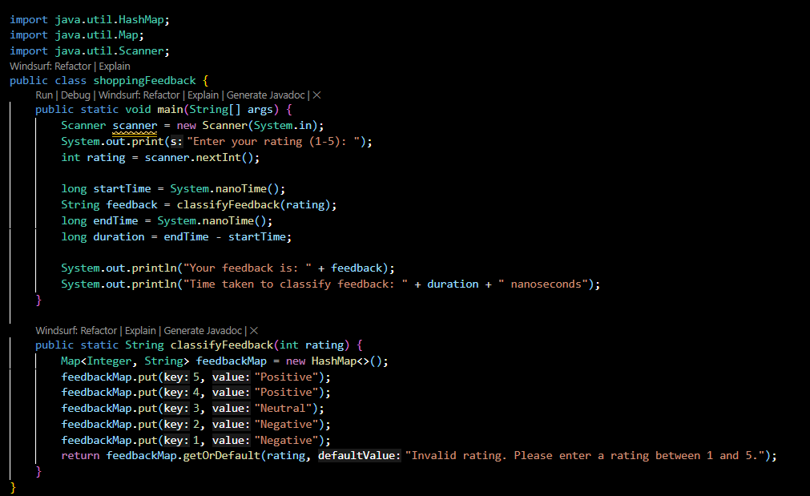
Output:
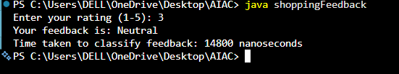
Explanation:
- Takes user input using the Scanner class.
- Records the start time using System. Nano Time().
- Calls the classify Feedback() method to determine feedback:
Ratings 4 and 5 → Positive
Rating 3 → Neutral
Ratings 1 and 2 → Negative
Any other value → Invalid rating message
- Calculates the execution time by finding the difference between start and end time.
- Displays the feedback result and the time taken in nanoseconds.
In the second version, a HashMap is used to map ratings directly to feedback categories,
making the code more concise and efficient than multiple conditional statements.

Task 3: Statistical_operations
Define a function named statistical_operations(tuple_num) that performs the
following statistical operations on a tuple of numbers:
• Minimum, Maximum
• Mean, Median, Mode
• Variance, Standard Deviation
While writing the function, observe the code suggestions provided by GitHub
Copilot.Make decisions to accept, reject, or modify the suggestions based on
their relevance and correctness
Prompt:
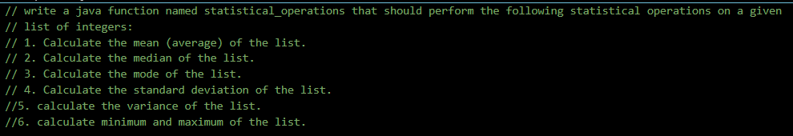
Code:
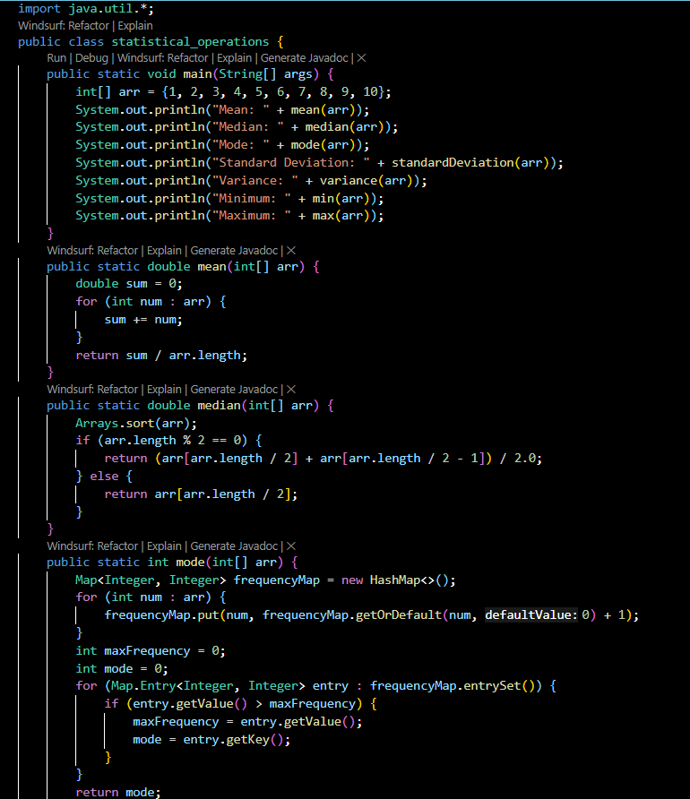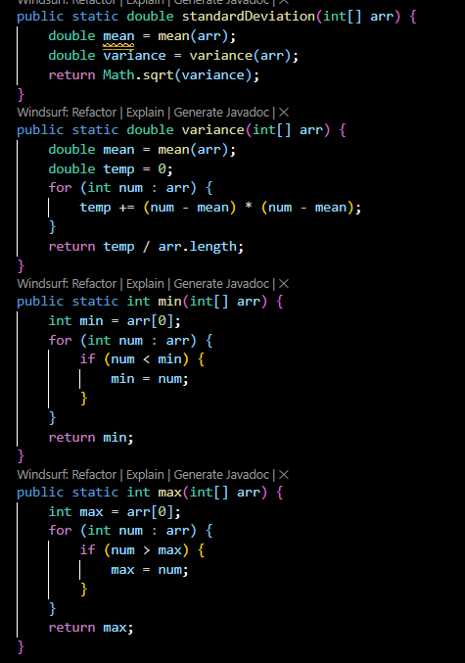
Output:
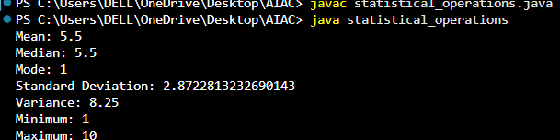
Explanation:
This Java program computes basic statistical measures for an integer array.
It calculates Mean, Median, Mode, Variance, Standard Deviation, Minimum, and Maximum using separate methods.
The program uses loops, sorting, HashMap, and mathematical formulas for accurate calculations.
It demonstrates modular programming and data analysis using Java.

Task 4: Teacher Profile
• Prompt: Create a class Teacher with attributes teacher_id, name,
subject, and experience. Add a method to display teacher details.
• Expected Output: Class with initializer, method, and object creation.
Prompt:
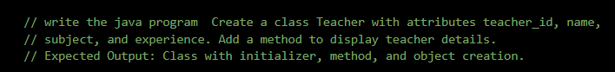
Code:
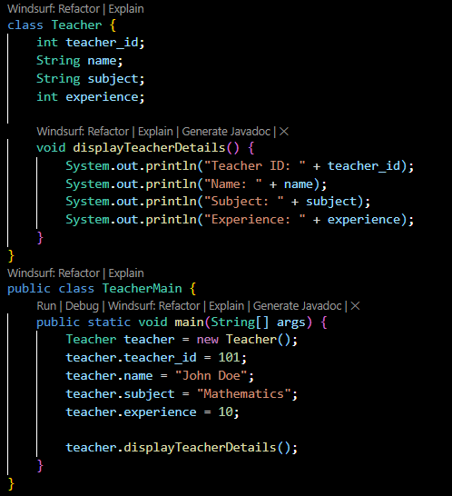
Output:
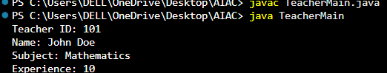
Explanation :
This Java program demonstrates basic Object-Oriented Programming (OOP) concepts.
The Teacher class contains data members such as teacher ID, name, subject, and experience, along with a method to display details.
The Teacher Main class creates an object of Teacher, assigns values to its variables, and calls the method to print the teacher’s information.
Task #5
Zero-Shot Prompting with Conditional Validation
Use zero-shot prompting to instruct an AI tool to generate a function
that validates an Indian mobile number.
Requirements
• The function must ensure the mobile number:
o Starts with 6, 7, 8, or 9
o Contains exactly 10 digits
Expected Output
• A valid Python function that performs all required validations
without using any input-output examples in the prompt.
Prompt:
Code:
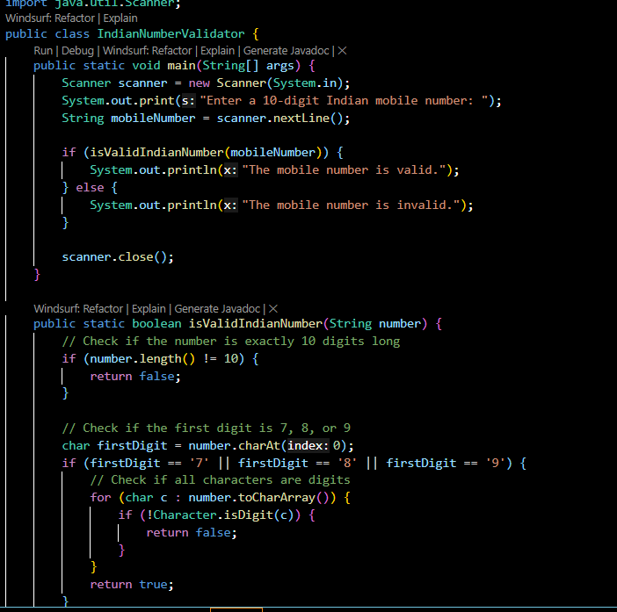
Output:
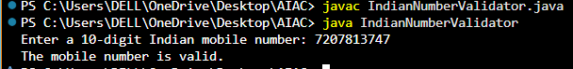
Explanation :
This Java program checks whether a given Indian mobile number is valid.
It verifies the length (10 digits), starting digit (7, 8, or 9), and ensures all characters are numeric.
The result is displayed as valid or invalid based on the validation.

Task Description #6
(Loops – Armstrong Numbers in a Range)
Task: Write a function using AI that finds all Armstrong numbers in a user-
specified range (e.g., 1 to 1000).
Instructions:
• Use a for loop and digit power logic.
• Validate correctness by checking known Armstrong numbers (153, 370,
etc.).
• Ask AI to regenerate an optimized version (using list comprehensions).
Expected Output #7:
• Python program listing Armstrong numbers in the range.
• Optimized version with explanation.
Prompt:
Code:
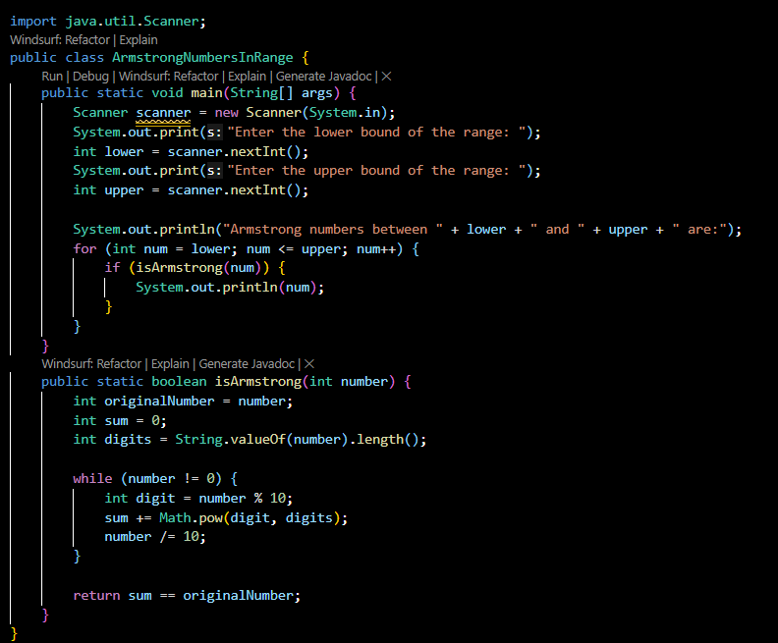
Output:
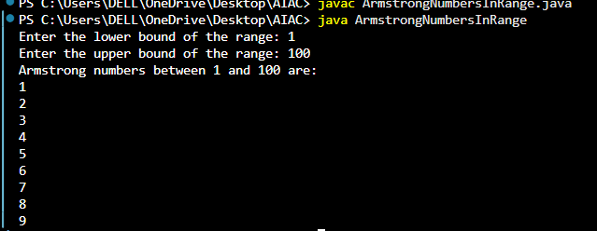
Prompt:
Code:
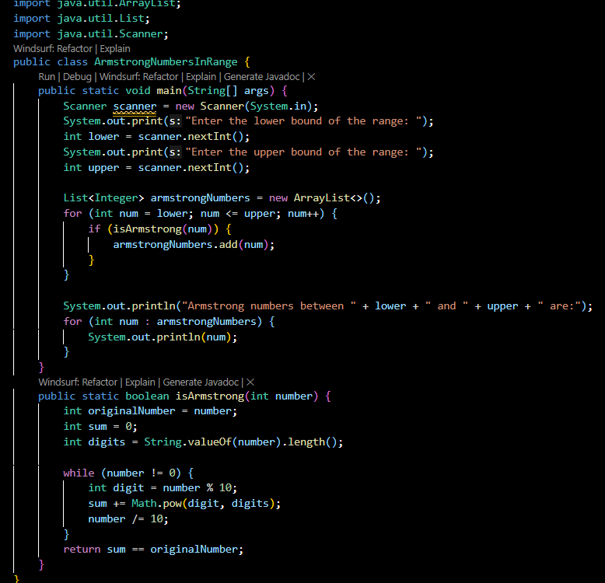
Output:
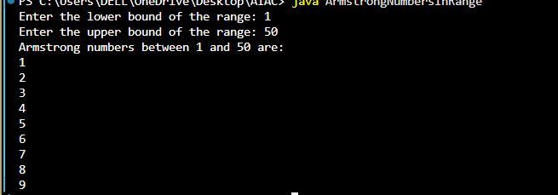
Task Description #7 (Loops – Happy Numbers in a Range)
Task: Generate a function using AI that displays all Happy Numbers within a
user-specified range (e.g., 1 to 500).
Instructions:
• Implement the logic using a loop: repeatedly replace a number with the
sum of the squares of its digits until the result is either 1 (Happy
Number) or enters a cycle (Not Happy).
• Validate correctness by checking known Happy Numbers (e.g., 1, 7, 10,
13, 19, 23, 28…).
• Ask AI to regenerate an optimized version (e.g., by using a set to detect
cycles instead of infinite loops).
Expected Output #8:
• Python program that prints all Happy Numbers within a range.
• Optimized version using cycle detection with explanation.
Prompt:
Code:
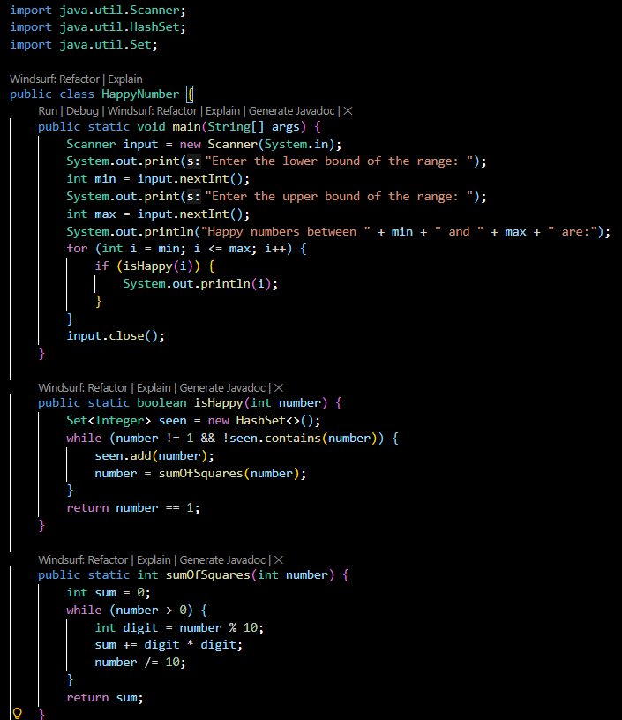
Output:
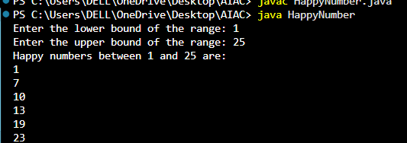
Prompt:
Code:
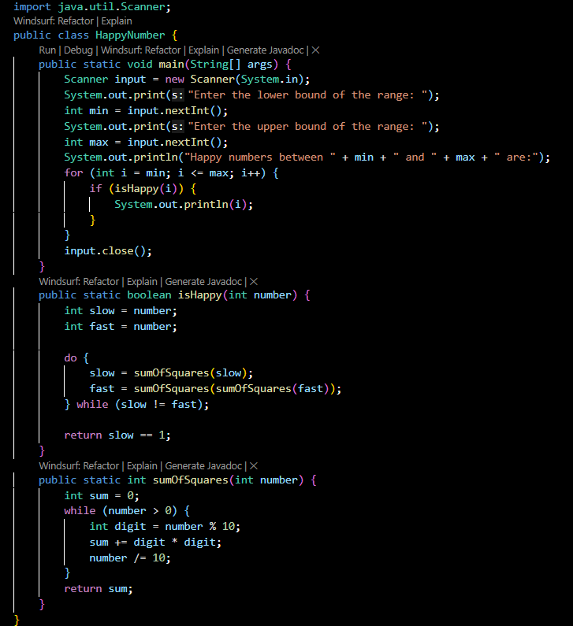
Output:
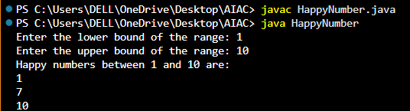
Task Description #8
Loops – Strong Numbers in a Range)
Task: Generate a function using AI that displays all Strong Numbers (sum of
factorial of digits equals the number, e.g., 145 = 1!+4!+5!) within a given range.
Instructions:
• Use loops to extract digits and calculate factorials.
• Validate with examples (1, 2, 145).
• Ask AI to regenerate an optimized version (precompute digit factorials).
Expected Output #9:
• Python program that lists Strong Numbers.
• Optimized version with explanation.
Prompt:
Code:
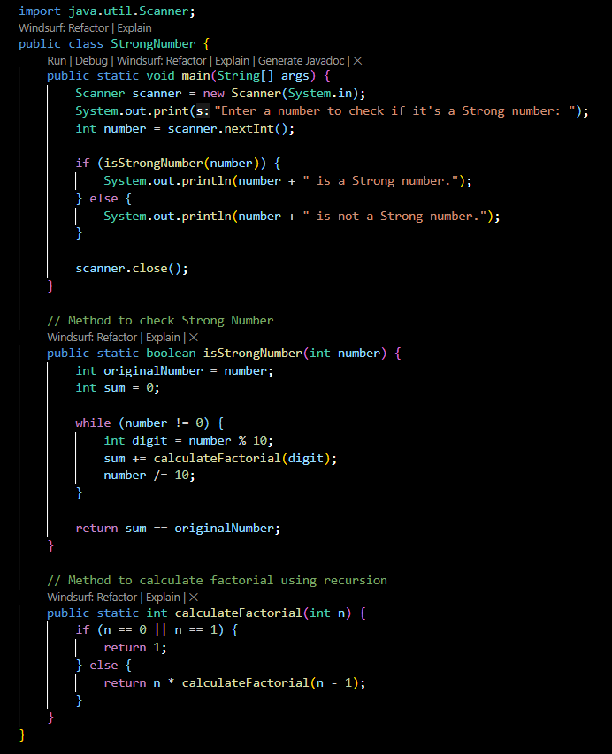
Output:
Prompt:
Code:
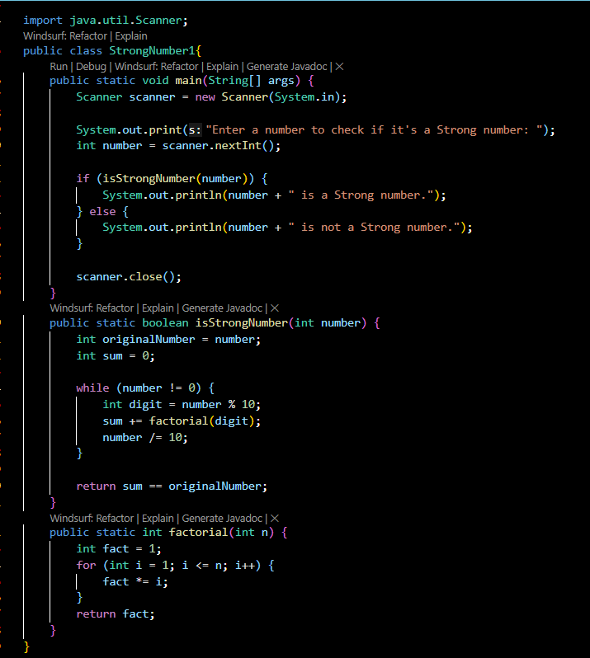
Output:

Task #9
Few-Shot Prompting for Nested Dictionary Extraction
Objective
Use few-shot prompting (2–3 examples) to instruct the AI to create a
function that parses a nested dictionary representing student
information.
Requirements
• The function should extract and return:
o Full Name
o Branch
o SGPA
Expected Output
A reusable Python function that correctly navigates and extracts values
from nested dictionaries based on the provided examples
Prompt:
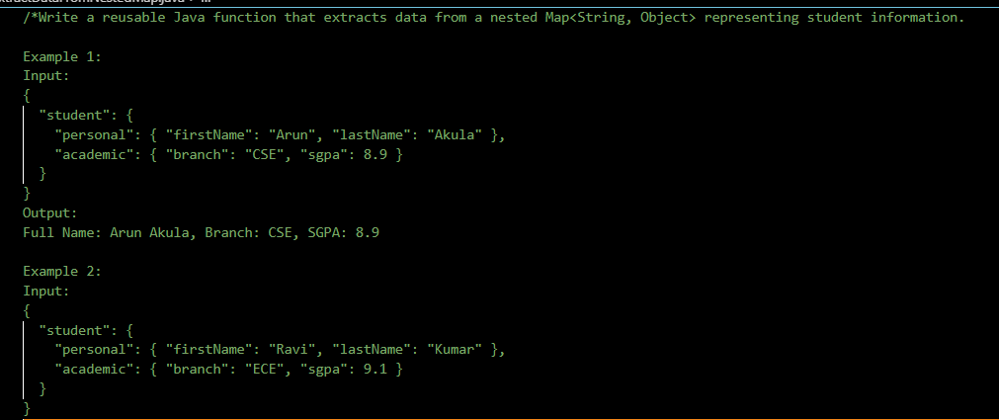
Code :
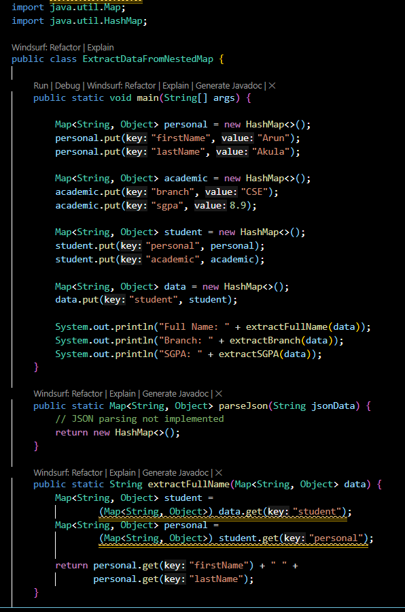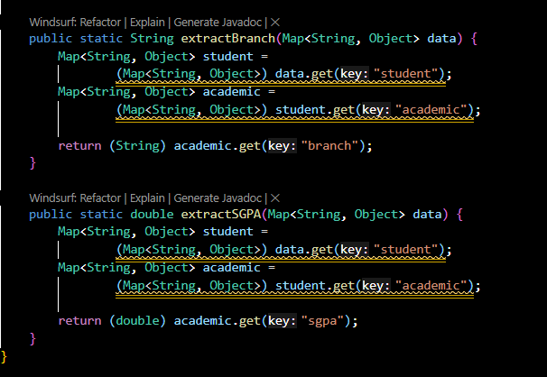
Output:
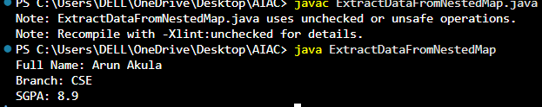

Task Description #10
(Loops – Perfect Numbers in a Range)
Task: Generate a function using AI that displays all Perfect Numbers within a
user-specified range (e.g., 1 to 1000).
Instructions:
• A Perfect Number is a positive integer equal to the sum of its proper
divisors (excluding itself).
o Example: 6 = 1 + 2 + 3, 28 = 1 + 2 + 4 + 7 + 14.
• Use a for loop to find divisors of each number in the range.
• Validate correctness with known Perfect Numbers (6, 28, 496…).
• Ask AI to regenerate an optimized version (using divisor check only up to
√n).
Prompt:
Code:
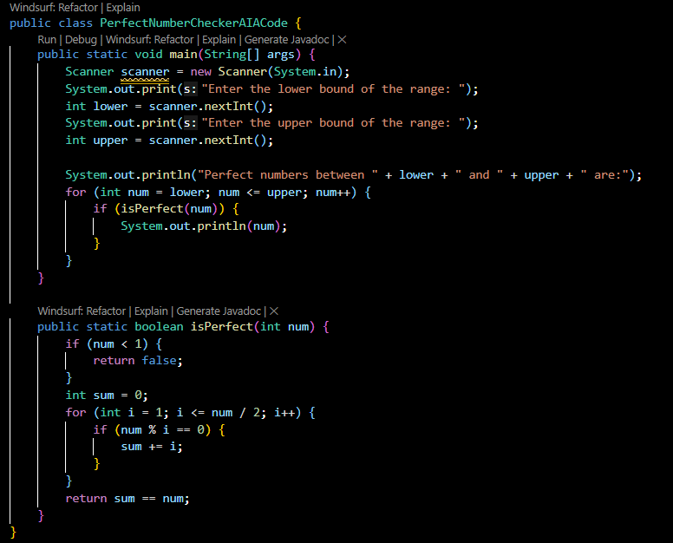
Output:
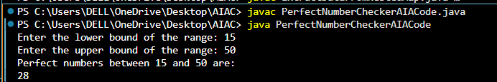
Prompt:
Code:
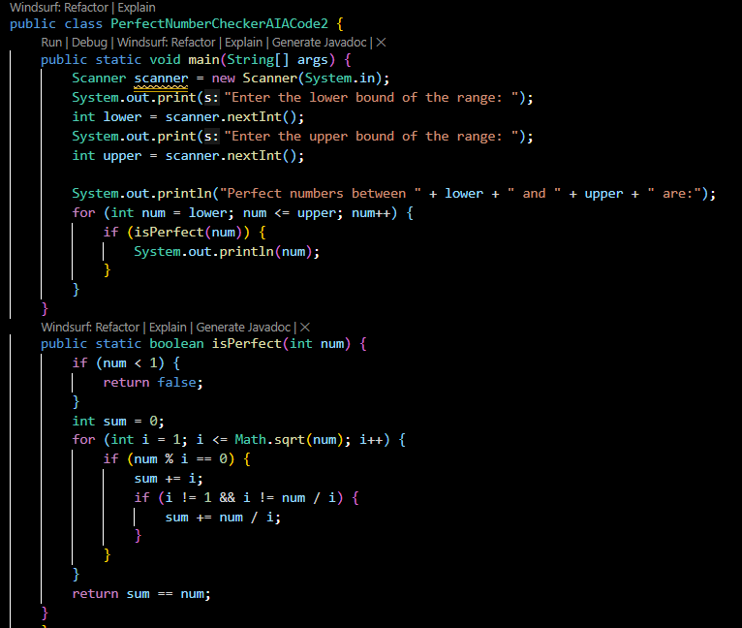
Output:
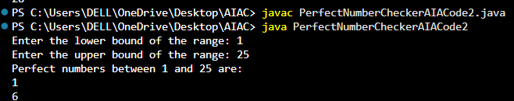
Explanation :
This Java program finds Perfect Numbers within a user-specified range.
A perfect number is one whose sum of proper divisors equals the number itself.
The first version checks divisors up to n/2, while the optimized version checks up to √n for better performance.
All perfect numbers in the given range are printed as output.

